**Customer**: Align Technology BV

**Date**: 14/6/2013

**Reference Number: VAT /CON/EVENT/PRICE/DISC**

**In/out hours:** In hours

**Code**

Deploy all phase II code from the PhaseII directory:

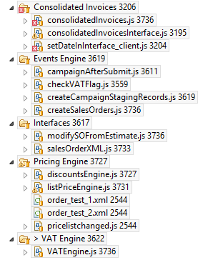

**CSV Export/Import VAT Rule Data (if required)**

Choose the “Align BV Schedule List” custom record set in DEV  
Ensure all records are selected i.e. no filters are present  
Choose Export – CSV in the bottom right corner of the list view  
In the target system i.e. ET, choose to import CSV, Setup>Import/Export and choose Add/Update for the import type for “Align BV Schedule List” custom record set

Repeat for :  
“Align BV EU Country Classify List” (if required)

Repeat for :  
“Align BV VAT Reg Codes List” (if required)

**Ensure the Event Sequence is Correct for Scripted Records**

**Events**

|  |  |
| --- | --- |
| Events Staging | customrecord_fhlevents |

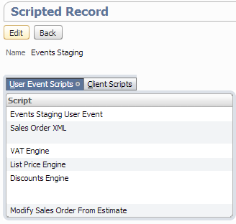

**Sales Orders**

|  |  |
| --- | --- |
| Sales Order | salesorder |

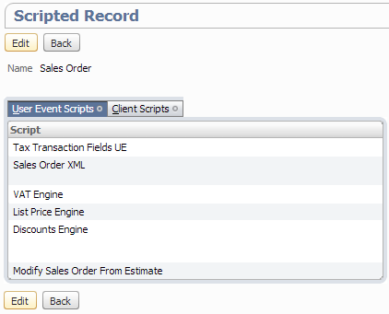

**Order Feed**

|  |  |
| --- | --- |
| TIBCO Order Feed | customrecord_tibco_order_feed |

